# Upper Yampa Water Conservancy District Board of Directors Meeting

**Wednesday, October 23, 2024 (12:00 PM) Mountain Valley Bank Community Room 2220 Curve Plaza, Steamboat Springs, CO Online Meeting:**

[**HTTPS://US06WEB.ZOOM.US/J/84541615581?PWD=QPMIZJ4AYXGPW5I4Z23JXUJUPSQCLJ.1**](https://us06web.zoom.us/j/84541615581?pwd=QpmIZj4ayXGpW5I4z23JxUjUpSQClj.1)

**Minutes**

Chairman Webster Jones called the meeting to order and declared a quorum present. In addition to Chairman Jones, the Board Members present were Jim Haskins, Katie Berning, Mynon Woodley, Tom Sharp and Nicole Seltzer. Board Members Lyn Halliday and Kevin McBride were present over Zoom. General Manager Andy Rossi, District Engineer Emily Lowell, Public Information and External Affairs Manager Holly Kirkpatrick, Business Manager Dianna Schoen, Finance Manager Karina Craig, and Community Programs Specialist Courtney Lynn were also present. General Counsel Bob Weiss was present over Zoom. Special Counsel Scott Grosscup was present over Zoom for a portion of the meeting. Member of the public present for some portion of the meeting included Luke Mecklenburg.

This meeting was held in person and by videoconference utilizing Zoom. The meeting agenda included instructions to the public describing the process to participate in the meeting and comment on agenda items.

The following agenda was proposed:

**Agenda**

1. **12:00 PM** Establishment of Quorum and Call to Order
2. **12:00 PM** Approval of Agenda for Meeting **Action item**
3. **12:05 PM** Public Input and Comment

The Board will make no decision nor take action, except to direct the General Manager. Those addressing the Board are requested to identify themselves by name, organization, if any, and address. Comments shall not exceed three (3) minutes.

* 1. Update from UYWG

1. **12:15 PM** Consent Agenda **Action item**
   1. Approval of the Minutes of the September 18, 2024, Board Meeting and acceptance of the minutes of the October 3, 2024 Strategic Planning/Board Governance Committee Meeting.
2. **12:20 PM** Report of General Manager
   1. 2025 Upper Yampa Water Conservancy District Budget Discussion
3. **2:30 PM** New Business (Limited to emergency matters that came up **Action item**

During the course of the meeting)

1. **2:35 PM** Executive Sessions:
   1. Executive session under CRS § 24-6-402(4)(b) to discuss legal issues on Water Resumes, Water Cases, Contract Negotiations and (insert description) . Mere presence or

participation of an attorney at an executive session is not sufficient to satisfy the requirements of CRS

§ 24-6-402(4)(b). Executive sessions to discuss legal matters are not recorded.

* 1. Executive session under CRS § 24-6-402(4)(e)(I) for the purpose of determining positions relative to matters that may be subject to negotiations; developing strategy for negotiations; and instructing negotiators with respect to (insert brief description). This session will be recorded, and a copy of the recording maintained for not less than 90 days.

1. **2:45 PM** Board Actions in Regard to Executive Session
2. **2:50 PM** Determination of Next Meeting(s) Agenda(s)
3. **3:00 PM** Adjournment.

Chairman Jones established a quorum and called the meeting to order at 12:05 PM.

***Meeting Agenda***. Director Seltzer moved to approve the agenda. Director Berning seconded the motion which was unanimously approved.

***Public Input and Comment***. Chairman Jones invited members of the public to comment on items not otherwise scheduled on the agenda. There was no comment.

***Consent Agenda***. Director Sharp moved to approve the Minutes of the September 18, 2024, Board Meeting with the following change. *During the Morrison Creek Water and Sanitation District (MCWSD) Inclusion Updates Director Sharp advised the Board that he is General Counsel for the MCWSD. Board members did not express that there was any conflict for him to continue to hear this matter.* In addition to a motion to approve the September 18,2024 minutes, Director Sharp moved to accept the minutes of the October 3, 2024 Strategic Planning/Board Governance Committee Meeting. Director Haskins seconded the motion which was unanimously approved.

***Report of General Manager***.

Upper Yampa Water Conservancy District Budget Discussion

General Manager Rossi presented the history of the UYWCD budgeting approval process and reviewed the format of the Updated DRAFT 2025 budget packet and what portion of the budget materials will be presented for final approval in November. Revenues and expenses were explained by General Manager Rossi. The Board reviewed and discussed the details of the proposed 2025 Budget components. Property tax revenues were discussed, and the impact of the closure of power plants and mines is expected to have an impact on future tax revenues. There was discussion on future expenditures to be allocated to water quality analysis and modeling. General Manager Rossi requested to increase Planning expenditures by $300,000 for this purpose. Chairman Jones noted that there were no objections by Board Members to increase expenditures for this purpose.

***Executive Session***. At 2:23 PM Director Sharp moved, Director Haskins seconded, and it was unanimously agreed to go into Executive session under CRS § 24-6-402(4)(b) to discuss legal issues on Water Resumes, Water Cases, Contract Negotiations and specifically negotiations involving litigation with Tri-State. Mere presence or participation of an attorney at an executive session is not sufficient to satisfy the requirements of CRS § 24-6-402(4)(b). Executive sessions to discuss legal matters are not recorded.

The Executive Session ended at 2:47 PM.

***Board Action Regarding Executive Session***. Director Sharp moved that as a consequence of the discussion in Executive Session that the Board of Directors approve the outline of the comprehensive settlement with Tri-

State on the four cases 22CW3002, 22CW3018, 22CW3107 and 22CW3108 that are mentioned in the settlement. Director McBride seconded the motion, which was unanimously approved.

***New Business***. There was no new business.

***Determination of Next Meeting Agenda***. The agenda for the November 20, 2024 Board Meeting was reviewed.

Director Berning moved to adjourn the meeting at 2:59 PM. Director Sharp seconded the motion which was unanimously approved.

I certify that the foregoing constitutes a true and correct summary of the proceeds at the above referenced meeting.

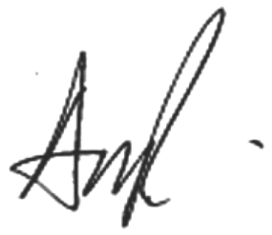

Andy Rossi, District Secretary/Manager

12/06/2024

Date:

STATEMENT FROM ATTORNEY REGARDING ATTORNEY-CLIENT PRIVILEGE

The undersigned Robert G. Weiss, legal counsel for the District, hereby attests, pursuant to CRS Section 24-6- 402(2)(d.5)(II)(B), that the portion of the executive session that was not recorded and which related to discuss legal issues on Water Resumes, Water Cases, Contract Negotiations and specifically negotiations involving litigation with Tri-State constituted a privileged attorney-client communication under CRS Section 24-6- 402(4)(b).

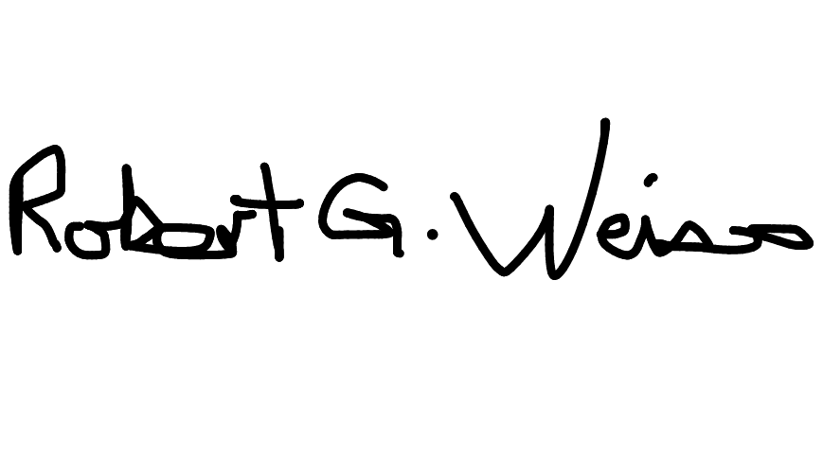

Robert G. Weiss, Counsel

15/12/2024

Date:

1023 2024 BOD Meeting Minutes - Final

Final Audit Report 2024-12-16

Created:

2024-12-06

By: Status:

Transaction ID:

Dianna Schoen [(dschoen@upperyampawater.com)](mailto:(dschoen@upperyampawater.com) Signed

CBJCHBCAABAAj09XyqdCf7ls05CoG8K-dFCGobHcNWbR

"1023 2024 BOD Meeting Minutes - Final" History

 Document created by Dianna Schoen [(dschoen@upperyampawater.com)](mailto:(dschoen@upperyampawater.com)

2024-12-06 - 8:46:10 PM GMT

 Document emailed to Andy Rossi [(arossi@upperyampawater.com)](mailto:(arossi@upperyampawater.com) for signature

2024-12-06 - 8:46:13 PM GMT

 Email viewed by Andy Rossi [(arossi@upperyampawater.com)](mailto:(arossi@upperyampawater.com)

2024-12-06 - 8:47:20 PM GMT

 Document e-signed by Andy Rossi [(arossi@upperyampawater.com)](mailto:(arossi@upperyampawater.com)

Signature Date: 2024-12-06 - 8:48:12 PM GMT - Time Source: server

 Document emailed to Bob Weiss [(bweiss@wvsc.com)](mailto:(bweiss@wvsc.com) for signature

2024-12-06 - 8:48:13 PM GMT

 Email viewed by Bob Weiss [(bweiss@wvsc.com)](mailto:(bweiss@wvsc.com)

2024-12-16 - 0:47:09 AM GMT

 Document e-signed by Bob Weiss [(bweiss@wvsc.com)](mailto:(bweiss@wvsc.com)

Signature Date: 2024-12-16 - 0:49:37 AM GMT - Time Source: server

 Agreement completed.

2024-12-16 - 0:49:37 AM GMT

